# [***82 FR 32123***](https://advance.lexis.com/api/document?collection=administrative-codes&id=urn:contentItem:5P0R-DPP0-006W-84J9-00000-00&context=)

Vol. 82, No. 132, Wednesday, July 12, 2017

Rules and Regulations

**Reporter**

82 FR 32123 *

***Federal Register* > *2017* > *July* > *Wednesday, July 12, 2017* > *Rules and Regulations* > *FEDERAL TRADE COMMISSION (FTC)***

**Title:** **Premerger Notification; Reporting and Waiting Period Requirements**

**Action:**  Final rule.

**Agency**

FEDERAL TRADE COMMISSION (FTC)

**Administrative Code Citation**

**16 CFR Part 803**

**Synopsis**

**SUMMARY:** The Commission, with the concurrence of the Assistant Attorney General, ***Antitrust*** Division, Department of Justice, announces ministerial changes to the ***Antitrust*** Improvements Act Notification and Report Form ("HSR Form") to make it conform to recently published amendments to the associated Instructions and to reflect changes to the noncompliance penalty and the Premerger Notification Office address.

**Text**

**SUPPLEMENTARY INFORMATION:** Section 7A of the Clayton Act (the "Act") requires the parties to certain mergers and acquisitions to file notifications with the Federal Trade Commission ("the Commission") and the Assistant Attorney General in charge of the ***Antitrust*** Division of the Department of Justice ("the Assistant Attorney General") (collectively "the Agencies") and to wait a specified period of time before consummating such transactions. The reporting requirement and the waiting period that it triggers are intended to enable the Agencies to determine whether a proposed merger or acquisition may violate the ***antitrust*** laws if consummated and, when appropriate, to seek a preliminary injunction in federal court to prevent consummation, pursuant to Section 7 of the Act.

Section 7A(d)(1) of the Act, [*15 U.S.C. 18a(d)(1)*](https://advance.lexis.com/api/document?collection=statutes-legislation&id=urn:contentItem:4YF7-GNJ1-NRF4-451X-00000-00&context=), directs the Commission, with the concurrence of the Assistant Attorney General, in accordance with the Administrative Procedure Act, *5 U.S.C. 553*, to require that premerger notification be in such form and contain such information and documentary material as may be necessary and appropriate to determine whether the proposed transaction may, if consummated, violate the ***antitrust*** laws. Section 7A(d)(2) of the Act, [*15 U.S.C. 18a(d)(2)*](https://advance.lexis.com/api/document?collection=statutes-legislation&id=urn:contentItem:4YF7-GNJ1-NRF4-451X-00000-00&context=), grants the Commission, with the concurrence of the Assistant Attorney General, in accordance with *5 U.S.C. 553*, the authority to define the terms used in the Act and prescribe such other rules as may be necessary and appropriate to carry out the purposes of § 7A. Pursuant to that authority, the Commission, with the concurrence of the Assistant Attorney General, developed the Rules, codified in 16 CFR parts 801, 802 and 803, and the HSR Form and its associated Instructions, codified at Part 803--Appendix. The Rules, codified in 16 CFR parts 801, 802 and 803, and associated Forms and Instructions, codified at Part 803--Appendix, to govern the form of premerger notifications to be provided by merging parties. The HSR Form is designed to provide the Commission and the Assistant Attorney General with the information and documentary material necessary for an initial evaluation of the potential anticompetitive impact of significant mergers, acquisitions and certain similar transactions.

**Changes to the HSR Form**

The Commission is amending the HSR Form so that it will conform to the recently published amendments to the associated Instructions and reflect changes in the noncompliance penalty and the Premerger Notification Office address. n1 The changes are as follows:

n1 [*81 FR 60257*](https://advance.lexis.com/api/document?collection=administrative-codes&id=urn:contentItem:5KKS-JF50-006W-83M3-00000-00&context=) (September 1, 2016).

1. *Fee Information* --The Commission has deleted the following language **[*32124]** (along with an attachment box) from page one of the HSR Form: "In cases where your filing fee would be higher if based on acquisition price or where the acquisition price is undetermined to the extent that it may straddle a filing fee threshold, attach an explanation of how you determined the appropriate fee." The Commission eliminated this requirement in its amended Instructions. Thus, the language and the box have been deleted from the HSR Form.

2. *Form Revised Date* --The HSR Form's "Revised Date" on the bottom of each page has been updated from "(rev. 08/18/11)" to "(rev. 01/02/2017)" to reflect the ministerial revisions described in this notice.

3. *Penalty* --The HSR Form, on page 10, refers to a noncompliance penalty of $ 16,000 per day. By statute, n2 the Commission is required to adjust its civil penalty amounts for inflation every January. The HSR Form has been amended to omit the specific dollar amount and instead cross-reference [*16 CFR 1.98(a)*](https://advance.lexis.com/api/document?collection=administrative-codes&id=urn:contentItem:5RHV-NCN0-008G-Y05S-00000-00&context=), which lists the inflation-adjusted civil penalty.

n2 Federal Civil Penalties Inflation Adjustment Act of 1990, *Public Law 101-410*, *104 Stat. 890*, as amended by the Federal Civil Penalties Inflation Adjustment Act Improvements Act of 2015, *Public Law 114-74*, sec. 701, [*129 Stat. 599*](https://advance.lexis.com/api/document?collection=statutes-legislation&id=urn:contentItem:5RTR-H470-0019-T3FP-00000-00&context=).

4. *PNO Address* --The address of the Premerger Notification Office ("PNO") on page 10 of the HSR Form has been updated to reflect the PNO's current address in Constitution Center.

5. *Electronic Form Version* --The Electronic Form Version has been updated from "1.0.1, 01/13/2012" to "1.0.2, 01/02/2017" to reflect the ministerial changes described in this notice.

**Administrative Procedure Act**

The Commission finds good cause to adopt these changes without prior public comment. Under the APA, notice and comment are not required "when the agency for good cause finds (and incorporates the finding and a brief statement of reasons therefore in the rules issued) that notice and public procedure thereon are impracticable, unnecessary, or contrary to the public interest." *5 U.S.C. 553(b)(3)(B)*.

The Commission is updating the HSR Form so that it will conform to the recently published amendments to the associated Instructions. This does not involve any substantive changes in the Rules' requirements for entities subject to the Rules. Accordingly, the Commission finds that public comment is unnecessary.

In addition, under the APA, a substantive final rule is required to take effect at least 30 days after publication in the **Federal Register** unless an agency finds good cause that the rule should become effective sooner. *5 U.S.C. 553(d)*. However, these are purely ministerial changes and do not constitute a substantive rule change. Therefore, the Commission finds good cause to dispense with a delayed effective date.

For these reasons, the Commission finds that there is good cause for adopting this final rule as effective on July 12, 2017, without prior public comment.

**Regulatory Flexibility Act**

Under the Regulatory Flexibility Act ("RFA"), *5 U.S.C. 601*-612, an agency must prepare a regulatory flexibility analysis for all proposed and final rules that describes the impact of the rule on small entities, unless the head of the agency certifies that the rule will not have a "significant economic impact on a substantial number of small entities." *5 U.S.C. 605(b)*. However, the RFA applies only to rules for which an agency publishes a general notice of proposed rulemaking. *5 U.S.C. 603(a)*, *604(a)*. As discussed above, the Commission has determined for good cause that the APA does not require notice and public comment on this rule. Accordingly, the RFA does not apply to this final rule.

**Paperwork Reduction Act**

These changes do not contain any record maintenance, reporting or disclosure requirements that would constitute agency "collections of information" that would have to be submitted for clearance and approval by the Office of Management and Budget under the Paperwork Reduction Act of 1995, [*44 U.S.C. 3501*](https://advance.lexis.com/api/document?collection=statutes-legislation&id=urn:contentItem:4YF7-GNM1-NRF4-408K-00000-00&context=)-[*3518*](https://advance.lexis.com/api/document?collection=statutes-legislation&id=urn:contentItem:4YF7-GKC1-NRF4-44S5-00000-00&context=).

***Regulations***

**List of Subjects in 16 CFR Part 803**

***Antitrust***.

For the reasons stated above, the Federal Trade Commission amends 16 CFR part 803 as set forth below:

1. The authority citation for part 803 continues to read as follows:

**Authority:** [*15 U.S.C. 18a(d)*](https://advance.lexis.com/api/document?collection=statutes-legislation&id=urn:contentItem:4YF7-GNJ1-NRF4-451X-00000-00&context=).

1. Revise the appendix to part 803 to read as follows:

**Appendix to Part 803--Notification and Report Form for Certain Mergers and Acquisitions**

BILLING CODE 6750-01-P **[*32125]**

**[*32126]**

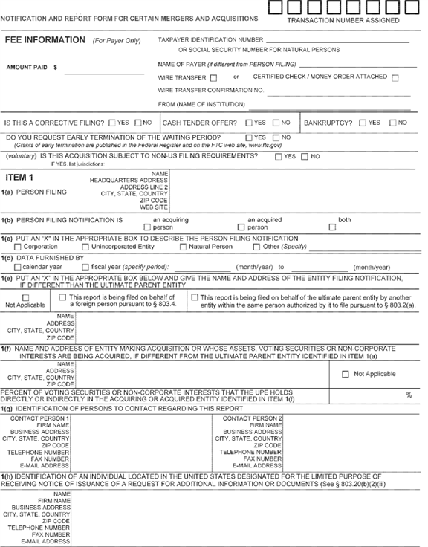

**[*32126]**



**[*32127]**

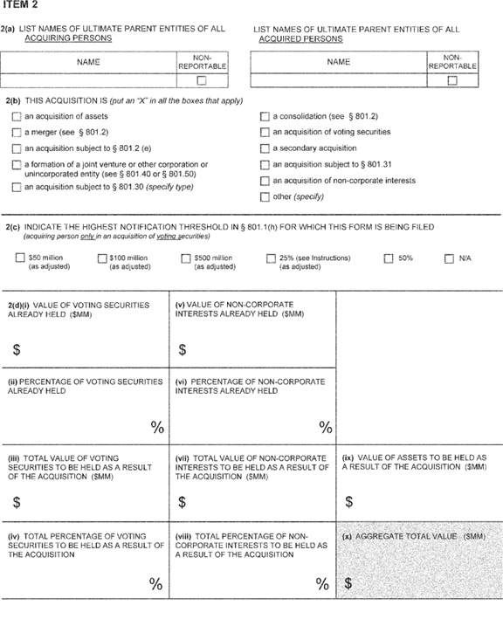

**[*32127]**



**[*32128]**

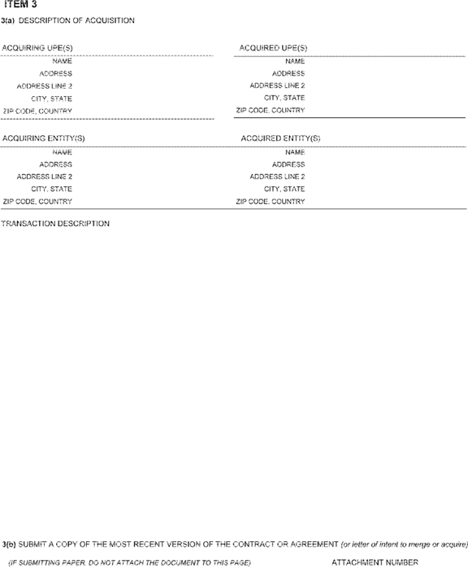

**[*32128]**



**[*32129]**

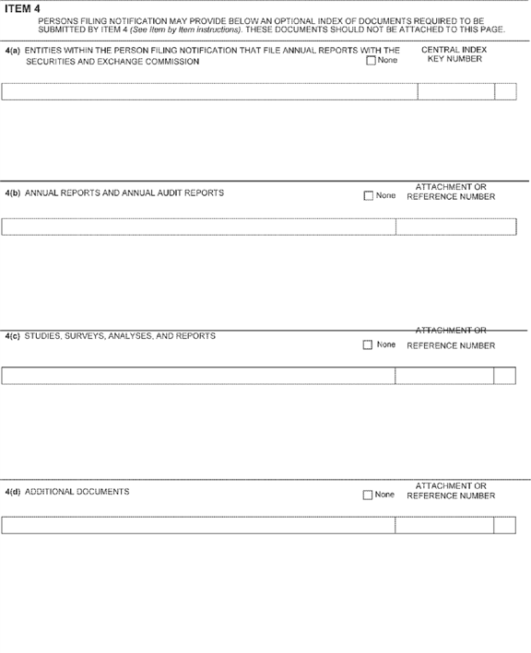

**[*32129]**



**[*32130]**

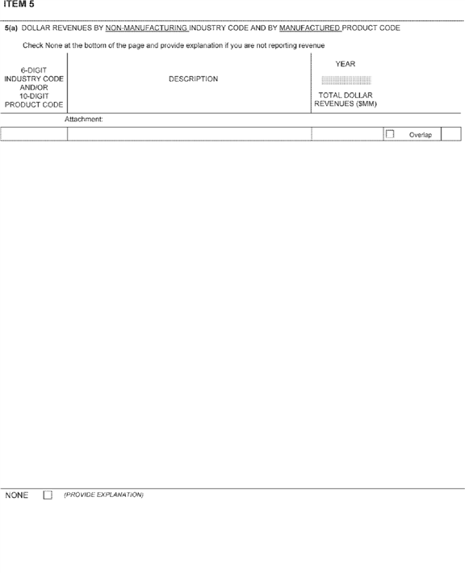

**[*32130]**



**[*32131]**

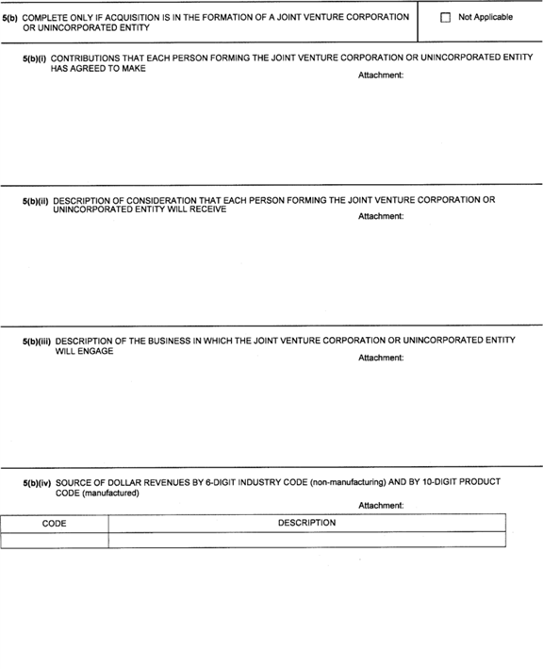

**[*32131]**



**[*32132]**

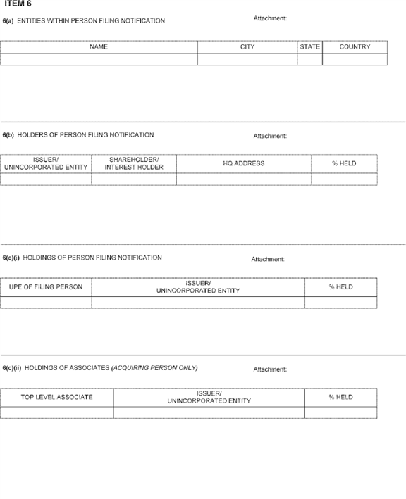

**[*32132]**



**[*32133]**

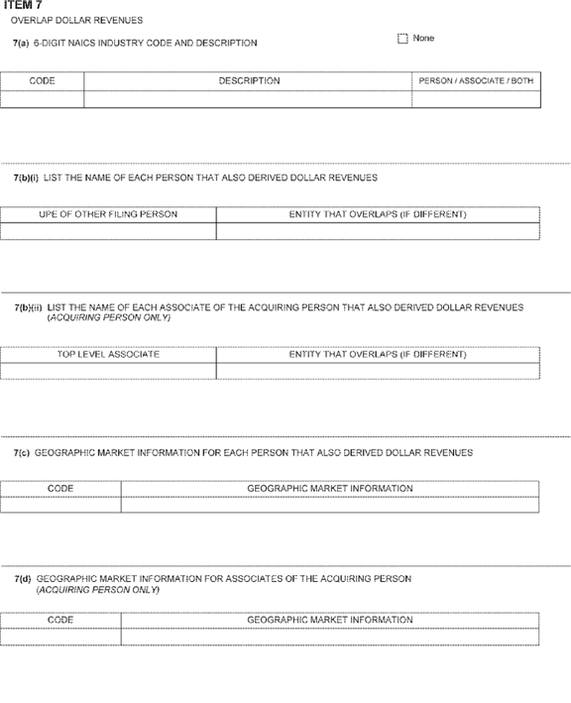

**[*32133]**



**[*32134]**

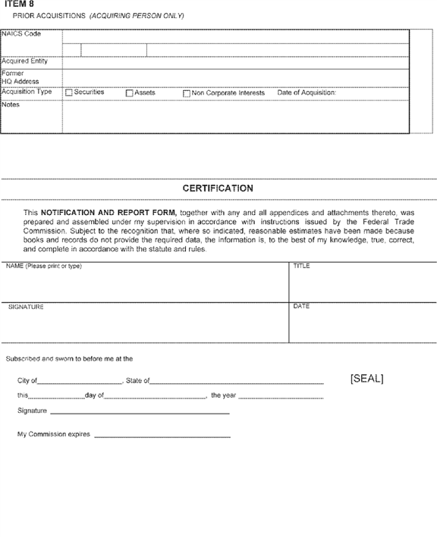

**[*32134]**

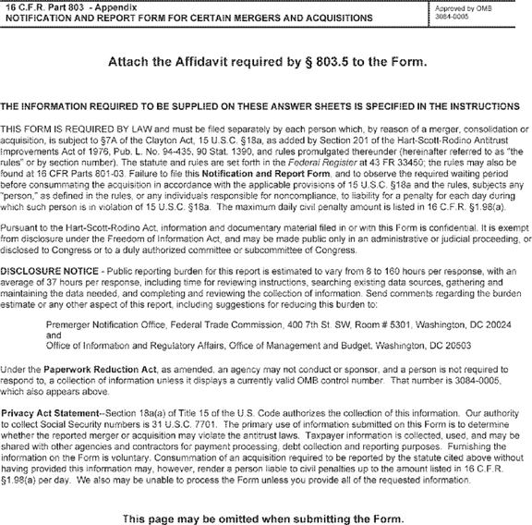

By direction of the Commission.

**Donald S. Clark,**

*Secretary.*

[FR Doc. 2017-14550 Filed 7-11-17; 8:45 am]

BILLING CODE 6750-01-C

**Dates**

**EFFECTIVE DATE:** Effective July 12, 2017.

**Contacts**

**FOR FURTHER INFORMATION CONTACT:** Robert Jones, Federal Trade Commission, Bureau of ***Competition***, Premerger Notification Office, 400 7th Street SW., Room #5301, Washington, DC 20024, Phone (202) 326-3100.

FEDERAL REGISTER

**End of Document**